- Create a Flask application with an /api route. When this route is accessed, it should return a JSON list. The data should be stored in a backend file, read from it, and sent as a response.
Code:
from flask import Flask, jsonify
import json

app=Flask(__name__)
@app.route('/api', methods=['GET'])
def get_data():
with open('data.json', 'r') as file:
data = json.load(file)
return jsonify(data)

if __name__ == '__main__':
app.run(debug=True)
json file:
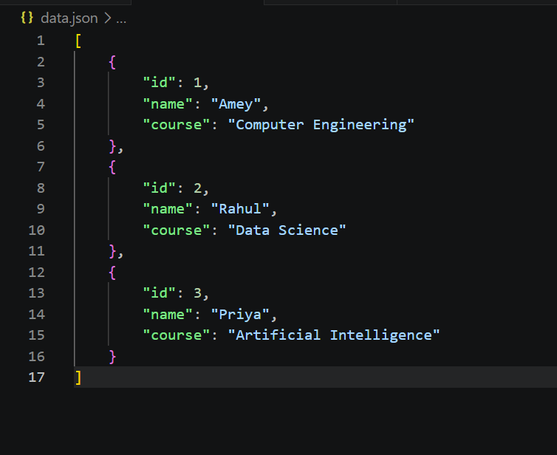
output:
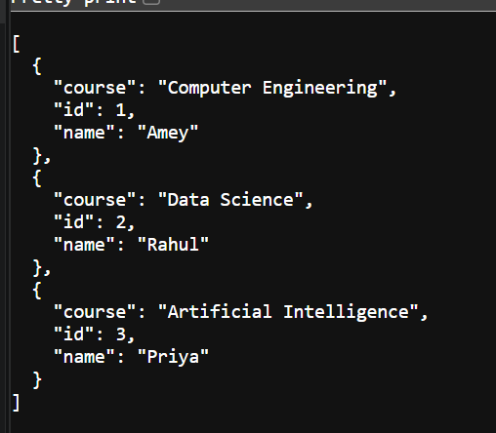
- Create a form on the frontend that, when submitted, inserts data into MongoDB Atlas. Upon successful submission, the user should be redirected to another page displaying the message "Data submitted successfully". If there's an error during submission, display the error on the same page without redirection.
Backend:- app.py
from flask import Flask, request, jsonify
from flask_cors import CORS
from pymongo import MongoClient
from dotenv import load_dotenv
import os

load_dotenv()

app = Flask(__name__)
CORS(app)

uri = os.getenv("MONGO_URI")

client = MongoClient(uri)

db = client["text"]
collection = db["flask_tutorial"]

@app.route("/submit", methods=["POST"])
def submit():

try:
data = request.json

collection.insert_one(data)

return jsonify({
"success": True,
"message": "Data submitted successfully"
}), 200

except Exception as e:

return jsonify({
"success": False,
"message": str(e)
}), 500

if __name__ == "__main__":
app.run(host="0.0.0.0", port=9000, debug=True)

frontend:-app.py
from flask import Flask, render_template, request, redirect, url_for
import requests

app = Flask(__name__)

@app.route("/")
def home():
return render_template("index.html")

@app.route("/submit", methods=["POST"])
def submit():

data = {
"name": request.form["name"],
"email": request.form["email"]
}

try:

response = requests.post(
"http://127.0.0.1:9000/submit",
json=data
)

result = response.json()

if result["success"]:
return redirect(url_for("success"))

else:
return render_template(
"index.html",
error=result["message"]
)

except Exception as e:

return render_template(
"index.html",
error=str(e)
)

@app.route("/success")
def success():
return render_template("success.html")

if __name__ == "__main__":
app.run(debug=True, port=8000)
output:-
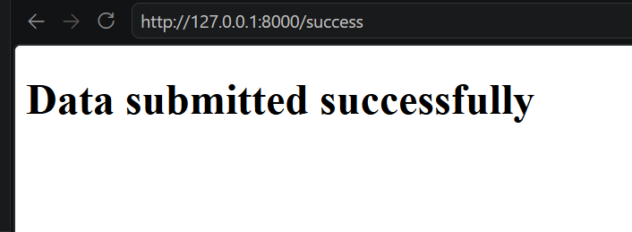
This application works using a frontend, a backend, and a MongoDB Atlas database. The frontend displays a form where the user enters details such as name and email. When the user clicks the Submit button, the form data is collected and sent to the backend using an HTTP POST request. The backend receives the data, connects to MongoDB Atlas using the MongoDB connection URI stored securely in the .env file, and inserts the submitted data into the specified collection. If the insertion is successful, the backend returns a JSON response indicating success, and the frontend redirects the user to a new page displaying the message "Data submitted successfully." If an error occurs, such as a database connection failure or any other exception, the backend returns an error message in JSON format. Instead of redirecting, the frontend displays this error message on the same form page, allowing the user to understand the problem and try submitting the form again. This approach provides a smooth user experience while ensuring proper communication between the frontend, backend, and MongoDB Atlas database.

